

Submitted by :

Fady Khalaf fahmy : sec 2

Maged Magdy Shokry :sec 2

Memory Management

Mini project

# Our project contains the features you asked for:

* Algorithms for allocating new processes in pre-defined holes
  + First fit algorithm
  + Best fit algorithm
  + Worst fit algorithm
* Graphical memory using java swing.
* Deallocating a specific process after allocating it
* There is a bit of mistake in hole id when deallocating a process but nothing wrong with starting or ending addresses.

# A simple user manual

1. Open application by doubling click on the .jar file
2. Choose number of holes and algorithm from the combo box as the picture

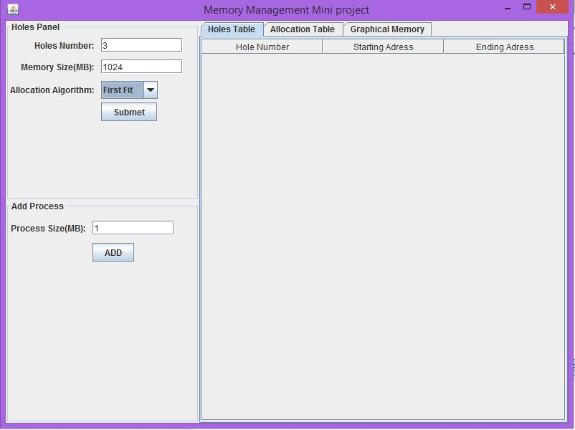

1. Process submit in order to appear in holes table

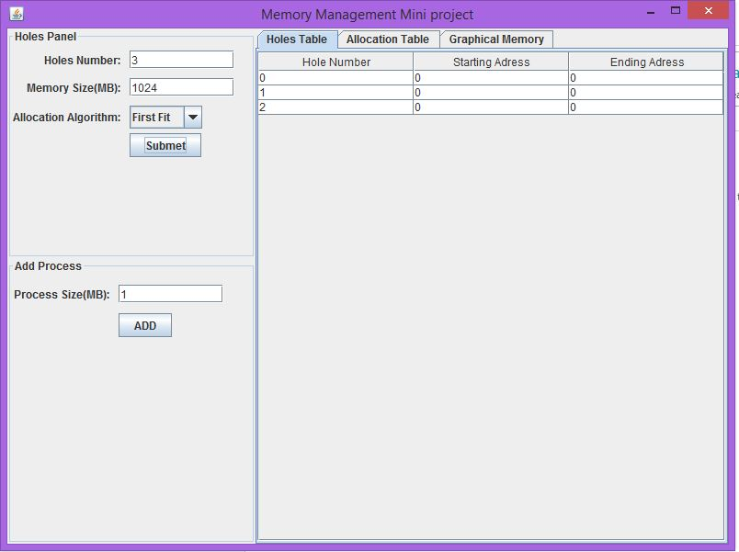

1. Update table cells as in my demo video
2. Enter a size of process and press submit to allocate one, u can see number of allocated processes in allocation table tab, also you can see graphical memory representation by clicking graphical memory tab as shown in my video demo.
3. You can deallocate a process:
   1. Click on allocation table tab
   2. Right click on one process and choose deallocate “this is shown at the video”